**Analysis of specific product**

1. Algorithm Visualizer [https://algorithm-visualizer.org/](https://algorithm-visualizer.org/backtracking/n-queens-problem)

Platform: web

Language support: English

Programming support: C++, JavaScript, Java

Algorithm support: all supported

Classification: it provides classifications for algorithms, e.g. brute force

Display: three module, code, animation and console

Search: it allows user to search a specific algorithm instead of finding by oneself

Appearance: modern design, but programmer oriented, code style

Explicit: step by step, clear structure of user interface

Open sourced: it provides the source code and fork option with github

Contact: it allows user issue and contact with the developers

Repository: multiple repos for algorithms, visualizer, etc.

Explanation: explain the algorithms in repo

https://github.com/algorithm-visualizer/algorithms/tree/master/Brute%20Force/Bubble%20Sort

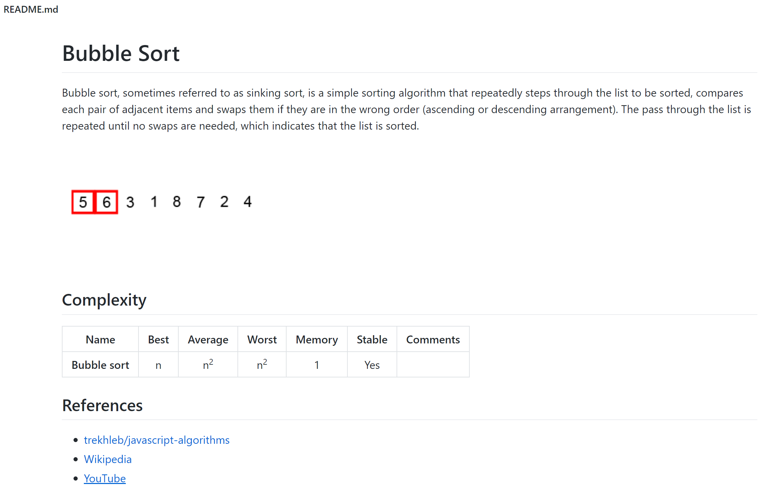

**Drawbacks**:

Lack of introduction and tutorial for newcomers

Lack of interaction with users

Language support only English

Difficult to understand how to make a new script to run in the platform

Not able to type in own data

2. WeChat Mini Program

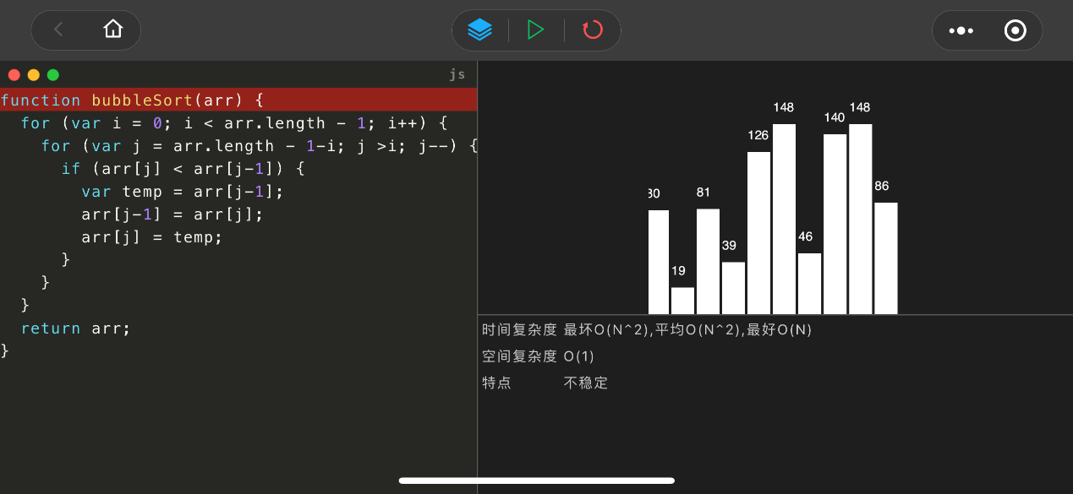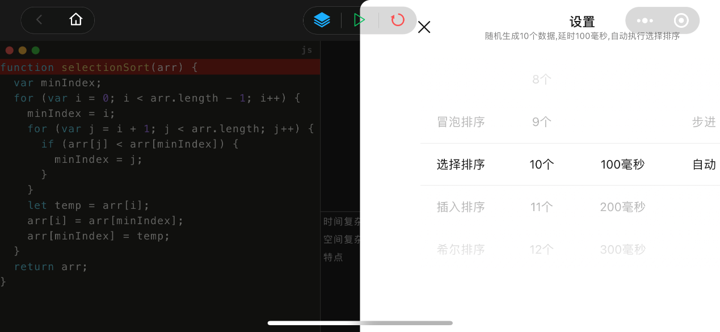

Multi-platform based on WeChat

Able to choose input size and algorithms

Appearance is simple and concise, easy to use

**Drawbacks**:

Few features

Unable to change the code

No interaction

Real programming language is not suitable for newcomers

3. iOS algorithm animation

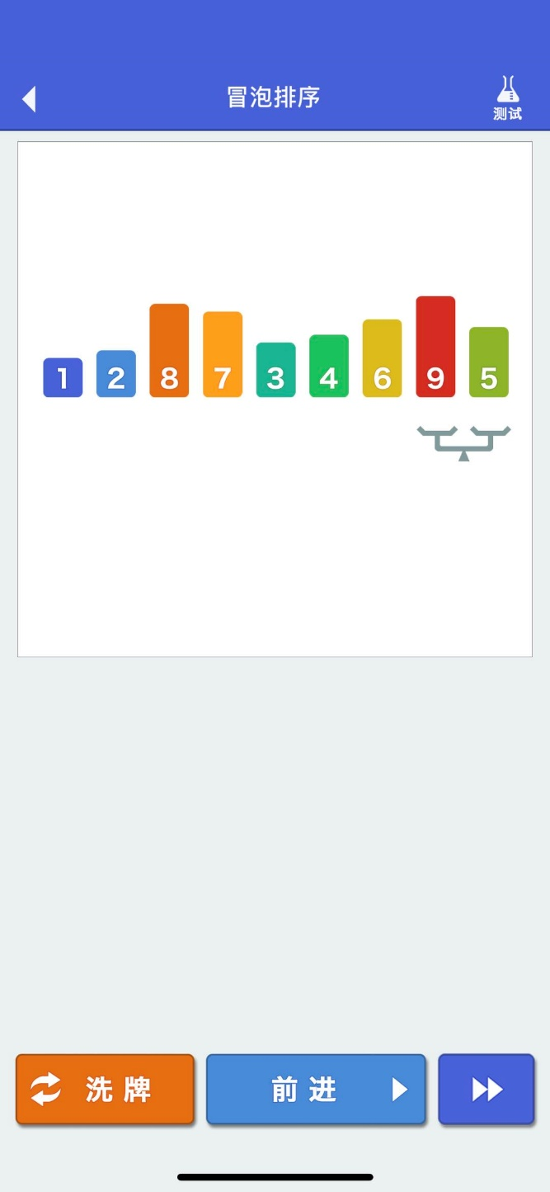

Two modules: teaching and practicing

**Drawbacks**:

Few features

Cannot input own array

No code presentation

No correctness provement

4. iOS iAlgo

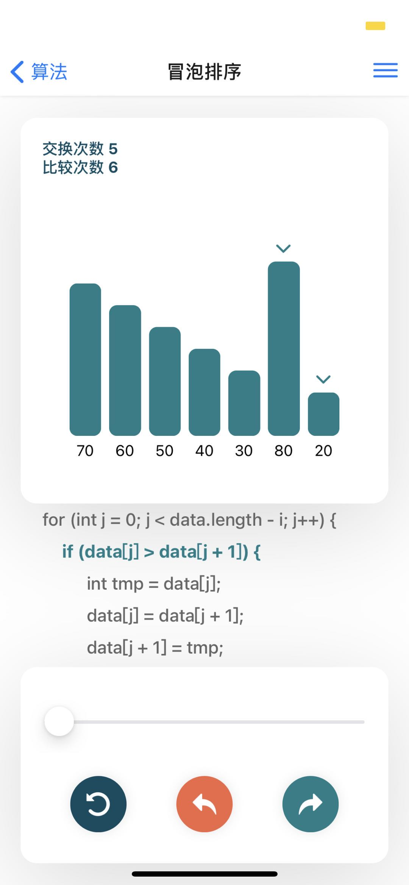

detailed tutorial for operations and description of algorithms

learning time count

collection feature for recording learning process

theme setting for colours

share feature for spread the app

feedback for improvement

language setting for both programming and prompt

modern design